I spent a bit of time learning about how website hosting works., it has been determined that the best place for us to buy our domain name for Accessible routes is from Squarespace.

This is the link that we would get it from:

<https://domains.squarespace.com/>

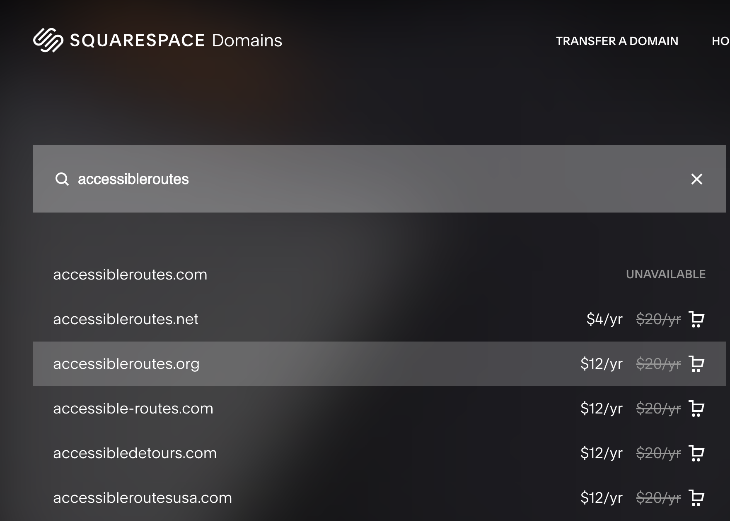

The domain name that we chose is accessibleroutes.org.

It will cost about $12 per year if bought during the sale. If bought outside of the sale, it will go up to $20. If the domain name is not paid for and renewed every year, it will expire.